Poitou Donkey Registry of America Registration Form

* Note: Please refer to Poitou Donkey Registration Tips for more information on naming conventions, DNA typing, microchipping and coat color:
(https://livestockconservancy.org/heritage-breeds/breed-registration/)

Proposed Registration Name (Submit 3 names in order of preference) * | 1.
 | 2.
 | 3.
“Barn” or “Pet” Name
Sex (if male, indicate if gelded)
DOB or approximate age
Color (brown or black) *
Other Registration # or IFCE # (this is for donkeys listed in other registries or registered in a European country)
Permanent ID (microchip #, tattoo #, brand, or tag)
Height at withers (if over 5 years of age) *
Approximate weight *
Sire Name and Registration #
Dam Name and Registration #
DNA Accession # or ID #/Laboratory Used
Breeder Information | Name:  Address:  Phone:  E-mail:
Owner Information | Name:  Address:  Phone:  E-mail:

Please note that your donkey’s registration cannot be completed until the registrar has a microchip number, photo and DNA test result on file. You may start the registration process and mail or email the other information when it is available. Your donkey’s registration papers will be mailed as soon as the registrar receives all your information.
These requirements protect your rights as owner of the donkey if it is lost or stolen or if its papers are ever lost. Your records also provide crucial information for the conservation of the breed.

Please draw in any distinguishing marks, color patterns, scars, whorls, stripes, etc. that will help identify the donkey. Further comments may be written on the back of the form.
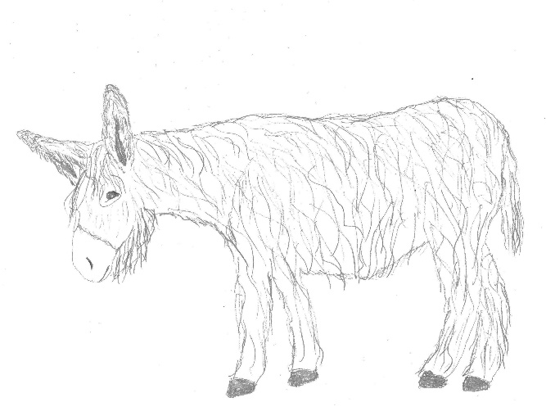  Other pedigree information, if known:  _______________________________________  Sire’s name | _____________________________________  Sire’s sire
_____________________________________
Sire’s dam
Dam’s Name | _____________________________________  Dam’s sire
_____________________________________
Dam’s dam

I (print name) ……………………………………………………………………………….., as the legal owner of the above-mentioned donkey, submit this registration application for acceptance into the Poitou Donkey Registry of America, held by The Livestock Conservancy Pedigree Registry. The information I have provided is accurate and complete to the best of my knowledge. I understand that acceptance into the registry does not imply an evaluation of animal soundness and may be cancelled or amended by The Livestock Conservancy Pedigree Registry at any time based on new information.

Signature of owner: …………………………………………………………………………… Date……………………………………

DNA Testing
Please collect a hair sample and fill out the Poitou Donkey DNA Submission Form. Mail them to the address printed on the form. The form can be downloaded here: https://livestockconservancy.org/heritage-breeds/breed-registration/ If your donkey was already DNA tested by The Livestock Conservancy, please note this on page 1.

Please initial the box below to authorize the Texas A&M Animal Genetics Laboratory to provide your donkey’s DNA test results to both you and to The Livestock Conservancy.

I agree to allow Texas A&M University to provide my donkey’s DNA test results to The Livestock Conservancy for registration purposes.

Photos
Please provide at least two good color photos (one from the front, and one from the side of the donkey’s body). The photos below are good examples. These can be emailed, any size jpg or sent by mail.

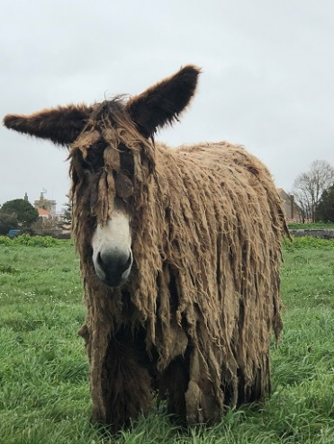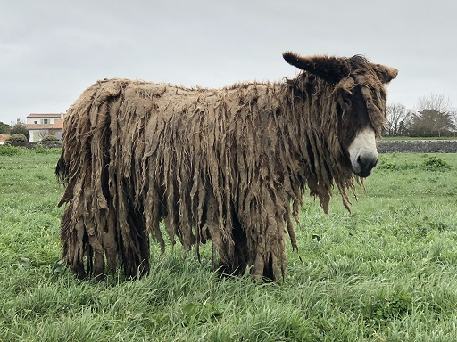

Please check to be sure you have completed each of these steps:

Fill out and sign the registration form (pages 1 and 2)

Initial the DNA test results permission box

Provide two photos of the donkey to Jaye Ray at jray@livestockconservancy.org

Pay registration fee, starting 2/1/2023 of $20 to: The Livestock Conservancy PO Box 477 Pittsboro, NC 27312 or online here: https://livestockconservancy.org/heritage-breeds/breed-registration/

Mail DNA sample and sample submission form and $50 to Texas A&M University. Payment instructions are on the form. The form can be found here: https://livestockconservancy.org/heritage-breeds/breed-registration/

Questions about registration?
Please contact Jaye Ray, Registrar
jray@livestockconservancy.org
919-542-5704, ext. 111

