Ossabaw Island Hog  Recovery Program Registration | 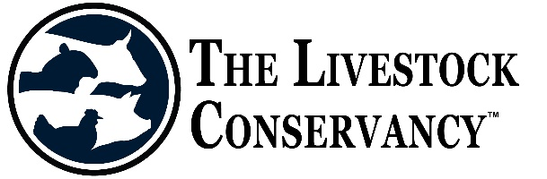
____________________________________________________________________________________
The Challenge - The Ossabaw hog faces many challenges as an endangered breed and one of the biggest has become the registration of purebred hogs. Breeders and owners that have chosen to not register their purebred breeding animals has resulted in important genetic diversity being lost to the breeding population. In an effort to recover some of this lost diversity, The Livestock Conservancy has chosen to create a Ossabaw Hog Recovery Program which investigates known purebred but unregistered animals and brings them back into the registry.

How it works – Owners answer the questions below and take a good frontal, rear, and two side images of the animal that can be included with the application. Photos of its sire and dam would also be very helpful. The Conservancy will then be in contact with you to determine if this animal can qualify for entry into the registry. Upon acceptance, the animal will be given an “R” designation after their registration number to identify this animal as being in the recovery program. Their offspring (F1 generation) will also be considered “recovery”, and will require photos to accompany their registration applications. They will receive an “R-1” designation after their registration number. The generation following (F2 generation) will be considered fully incorporated into the registry if breeding occurs with fully registered or R-1 pigs. This generation will not have the recovery designation as the others. To proceed please provide the following:

Name of animal -
Sex -
Age (actual or approximate) -
ID/tag – (all recovery pigs must be individually identified)
Color -

Owner name and contact -

Breeder name and contact -

Name of Sire:

Name of Dam:

Where did this animal come from? (Who farrowed it, where did you buy it, all known information and other history of the animal including origin of sire and dam)

Were its parents or grandparents intermixed or interbred with other breeds of pig at any time? -

Mail or email form along with PHOTOS and $6 to:
The Livestock Conservancy, PO Box 477, Pittsboro, NC 27312
Email form and photos to: jray@livestockconservancy.org
You may also pay online: LivestockConservancy.org

