Box 477, Pittsboro, NC 27312  Ph. 919-542-5704 fax: 919-545-0022  jberanger@livestockconservancy.org  Application for Individual Registration:  Wiltshire Horn Sheep | 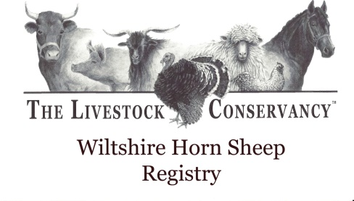
_______________________________________________________________________________________________________
Name: Description: Color Markings
Date of Birth: Face:
Ear Tag No.: Legs:
Sex: Belly:
S/Tw/Trp:

Fleece/Tail/Horns
Fleece: wooly / hairy/ sheds Tail: long / docked
Horns:

Sire Name/Ear tag No.: Sire Reg.No:
Sire bred by:

Dam Name/Ear Tag No.: Dam Reg. No.:
Dam bred by:

Breeder:
Address:
Phone:
e-mail:

Owned by:
Address:
Phone:
Email:

TRANSFER - I hereby notify the transfer of ownership of:

Reg. No.: __________Name: ________________ Tag No.: _______
Name: ________________________________
Address: ________________________________
________________________________
Phone: ________________________________
Date: __________________ Signature: ____________________

Return form to The Livestock Conservancy Livestock, PO Box 477, Pittsboro, NC 27312.
Or email form to: Jberanger@livestockconservancy.org
Please include a $4.00 registration fee per animal.
You may also pay online: LivestockConservancy.org

