Box 477, Pittsboro, NC 27312  Ph. 919-542-5704 fax: 919-545-0022  amartin@livestockconservancy.org  Application for Individual Registration:  Santa Cruz Island Sheep | 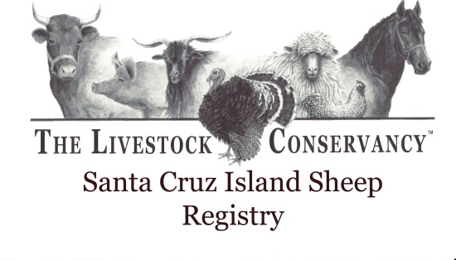
----------------------------------------------------------------------------------------------------------------------------
Animal Name:
Date of Birth:
Tag #:
Sex (Male/Female):
(Single/Twin/Triplet):
Horned/Polled:

Sire Name/Ear tag No.: Sire Reg. #:
Sire bred by:
Sire's Sire Name--Reg. #/Tag #:
Sire's Dam Name--Reg. #/Tag #:

Dam Name/Ear tag No.: Dam Reg. #:
Dam Bred By:
Dam's Sire Name--Reg. #/Tag #:
Dam's Dam Name--Reg. #/Tag #:
---------------------------------------------------------------------------------------------------------------------
Breeder Name:
Address:
Phone: Email:

Owner Name:
Address:
Phone: Email:
---------------------------------------------------------------------------------------------------------------------
Description:
Horns |  | Horned/Polled/Scurs
 | Color and Markings | Fleece
Face |  | Wooly / Bare
Legs |  | Wooly / Bare
Belly |  | Wooly / Bare
Fleece |  | Wooly / Hairy / Sheds
Tail | n/a | Long/Docked

Mail or email form to The Livestock Conservancy Livestock, PO Box 477, Pittsboro, NC 27312

Email form to: amartin@livestockconservancy.org
Please include a $4.00 registration or transfer fee per animal.
You may also pay online: LivestockConservancy.org

