The Livestock Conservancy Pedigree Registry
Santa Cruz Horse Registration Form

Proposed Registration Name (Submit 3 in order of preference) | 1.
 | 2.
 | 3.
“Barn” or “Pet” name
Sex
DOB or approximate age
Color
Horse ID
(brand, microchip#, tattoo#, etc.)
Sire Name/Reg. #
Dam Name/Reg #
Breeder Name & Contact | Name:  Address:  Phone:  E-mail:
Owner Name & Contact | Name:  Address:  Phone:  E-mail:

Draw in below any distinguishing marks, color patterns, scars, whorls, etc. that will identify the horse to be registered. Further comments on this horse may be written on the back of the registration form.
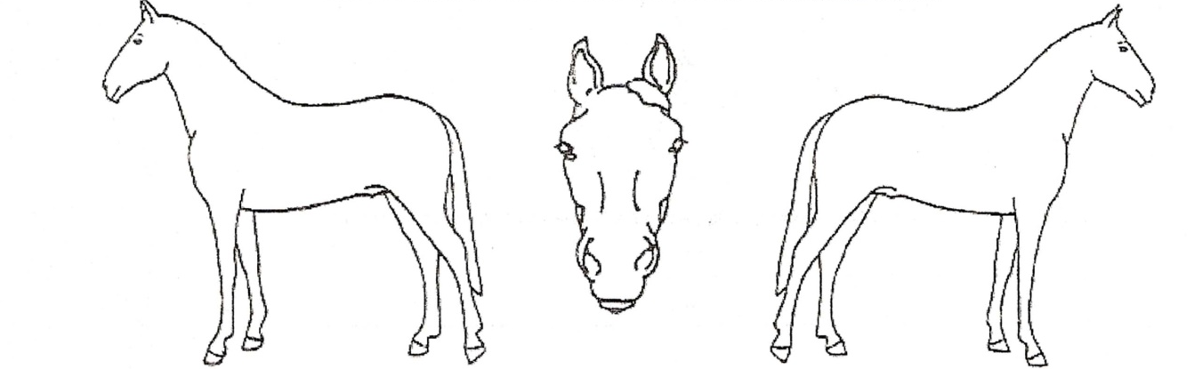

I (print name)………………………………………………………………………as the owner of the above mentioned horse submit this registration application for acceptance into the Santa Cruz Horse Registry held by The Livestock Conservancy Pedigree Registry. The information is accurate to the best of my knowledge. I understand that acceptance into the registry does not imply an evaluation of animal soundness and may be cancelled or amended by the TLC Pedigree Registry at any time based on new information.

Signature of owner……………………………………………………………………………Date……………………………………

Mail or email completed forms along with two photos (one of the front and one of the side of the horse) to
The Livestock Conservancy, PO Box 477, Pittsboro, NC 27312, jberanger@livestockconservancy.org or call 919-542-5704 ext 103

