Box 477, Pittsboro, NC 27312  Ph. 919-542-5704 fax: 919-545-0022  jberanger@livestockconservancy.org  Application for Individual Registration:  Ossabaw Island Hog | 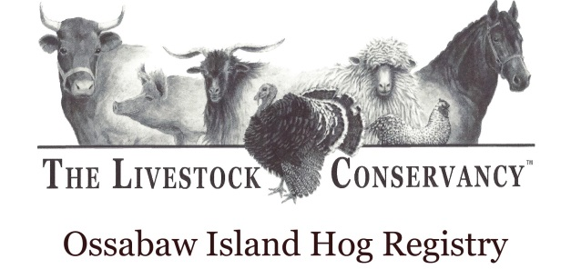

_________________________________________________________________________________________

Date: Reg. No (office use only):

Name of pig:

Date of birth:

Number of piglets in litter:

Identification No., ear tag No.:

Sex:

Color:
---------------------------------------------------

Sire Name/Ear tag No.: Sire Reg. No:

Dam Name/Ear Tag No.: Dam Reg. No.:

----------------------------------------------------
Breeder:

Address:

Phone: email:

----------------------------------------------------
Owned by:

Address:

Phone: email:

Signature: _______________________________________Date:_________________

Mail or email form to The Livestock Conservancy Livestock, PO Box 477, Pittsboro, NC 27312
Email form to: Jberanger@livestockconservancy.org
Please include a $4.00 registration fee per animal.
You may also pay online: LivestockConservancy.org

